ACS Data Preparation
State-level socioeconomic variables were obtained from the U.S. Census Bureau’s American Community Survey (ACS) 1-year estimates through the Census API. Two indicators were extracted for this analysis: income inequality and educational attainment. Income inequality was measured using the Gini Index from table B19083 (B19083_001E), while educational attainment was measured as the percentage of adults aged 25 years and older with a bachelor’s degree or higher, obtained from subject table S1501 (S1501_C02_015E).
https://data.census.gov/table/ACSST1Y2024.S1501?q=S1501
https://data.census.gov/table?q=B19083
Data were collected annually at the state level using the API parameter for=state:*. During the retrieval process, we found that the ACS 1-year dataset was unavailable for 2020, which resulted in a 404 response from the Census API. To maintain a consistent annual dataset, 2020 observations were excluded, leaving a final time span of 2015–2019 and 2021–2023.

After retrieving the data, several cleaning steps were performed. Variables were converted to numeric format, unnecessary columns were removed, and U.S. territories (FIPS codes 60, 66, 69, 72, and 78) were excluded so that the dataset contains only the 50 states and the District of Columbia. Data validation confirmed that there were no missing values and that each state-year combination appeared exactly once.

The final ACS dataset is a balanced state-year panel with 408 observations and five variables, including the state name, FIPS code, year, Gini index, and educational attainment.
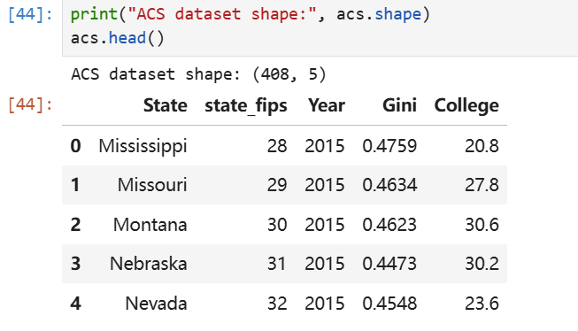
Table 1. Example of the Cleaned ACS Dataset
Each observation represents a state-year record, as shown in the example above.

Exploratory Patterns

To understand the distribution of the variables, we first examined the relationship between income inequality and educational attainment across state-year observations.
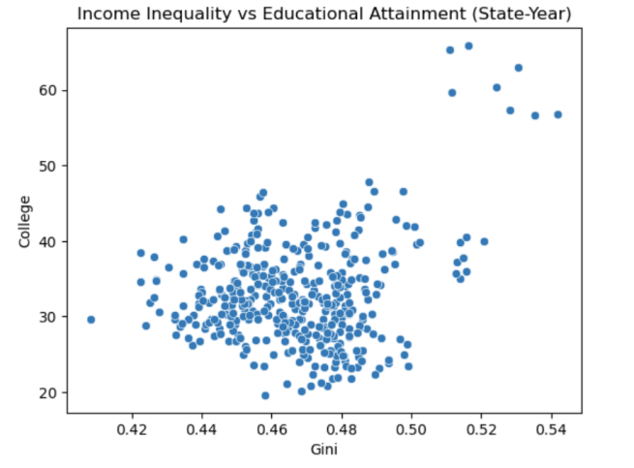
Figure 1. Income Inequality vs Educational Attainment (State-Year)
The scatterplot shows that most states cluster between Gini values of 0.44–0.49 and college attainment levels of roughly 25–40%, while a few observations with very high educational attainment likely correspond to highly educated regions such as the District of Columbia or northeastern states.

We also examined how the average values of these variables changed over time.

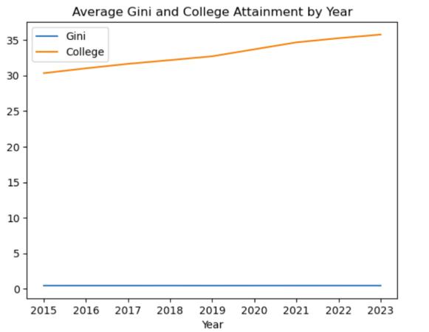
Figure 2. Average Gini and College Attainment by Year

Educational attainment shows a clear upward trend over the study period, increasing from approximately 30% in 2015 to nearly 36% in 2023, while the average Gini index remains relatively stable around 0.46–0.47.

Summary statistics for the dataset further confirm that the variables fall within expected national ranges.

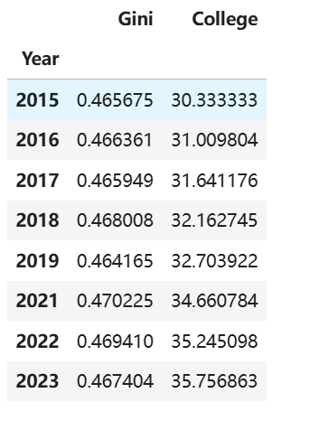
Table 1. Average Gini and College Attainment by Year

Across the dataset, the mean Gini index is approximately 0.467, while the average share of adults with a bachelor’s degree or higher is about 33%.
Finally, the cleaned dataset contains the following structure:
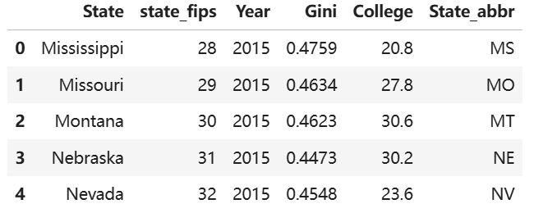
Table 2. Example of the Cleaned ACS Dataset

Each observation represents a state-year record, including the state name, FIPS code, year, income inequality, and educational attainment.

The resulting dataset will be merged with BRFSS depression prevalence data and BLS unemployment rates to construct the final state-year panel dataset used in the predictive analysis.

